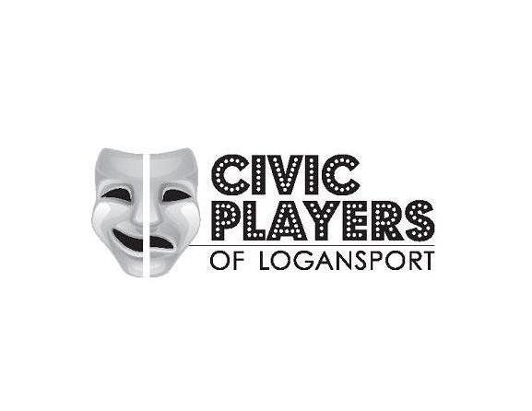
REQUEST TO DIRECT
Please email completed form to
civicplayersoflogansport@outlook.com
Or mail to the address below
NAME: PRODUCTION:

Producer:
Asst. Dir.:
Music Dir. (Musical Submissions Only):
Choreography (Musical Submissions Only):
Set Const.:
Props:
Costuming:
Lighting:
Sound:
Stage Manager:

CONTACT INFORMATION:

PREVIOUS DIRECTING EXPERIENCE:
(Please attach additional pages if needed)

PREVIOUS STAGE OR PRODUCTION EXPERIENCE:
(Please attach additional pages if needed)

TENTATIVE PRODUCTION STAFF:
PREFERRED VENUE:

PREFERRED SEASON
(Fall, Spring, Summer):

PREFERRED PRODUCTION SEASON
(Ex. 2017-2018):

DESCRIBE YOUR CREATIVE VISION FOR THIS PRODUCTION:

By signing and submitting this request, you, and your Production Staff, agree to abide to the rules and guidelines set forth by the Board of Directors of the Civic Players of Logansport.

DATE: SIGNATURE:

